MS
M S International
- Kanpur, Uttar Pradesh, India
- GST 09AJBPG3836G1ZD
|
Verified Supplier
- 3.3/54 RatingsWrite a Review
Send Inquiry
View Mobile Number
- Home
- Company Overview
- Our Products
- Contact Us

- Directory
- M S International
- Herbal Bidi
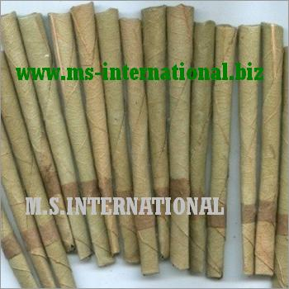

Herbal Bidi
Product Details:
Our organization is actively involved in manufacturing, supplying, exporting and wholesaling a premium grade Herbal Bidi. Everyone knows that smoking is harmful to health, but for those who cannot liv...
View Complete Details
Send Inquiry
- Product Details
- Company Details
Product Description
Our organization is actively involved in manufacturing, supplying, exporting and wholesaling a premium grade Herbal Bidi. Everyone knows that smoking is harmful to health, but for those who cannot live without smoking, this bidi is the best option. We provide herbal bidis to customers which is safe for the human body and also gives proper satisfaction to the smokers. This Herbal Bidi is available at a very leading price.
About M S International
166/3 Shastri Nagar, Kanpur, Uttar Pradesh, India - 208005
Nature of Business | Manufacturer, Exporter, Importer, Wholesale Supplier / Wholesaler, Retailer
Primary Business | Exporter
Company CEO | Manish
Total Number of Employees | Less than 10 People
Year of Establishment | 1979
Beyond 30 rich years of experience and excellence is the name “M. S. International”. M.S.I is a group reckoned for its distinctive Tobacco Products. Initiated with just Tobacco Leaf; Tobacco Products, Chewing Tobacco, Mouth Freshener, Mint Products, Aromatherapy Oil, Carrier Oil, Leather Belt, Golden Virginia Tobacco, Herbal Cigarettes, Khaini, Black Tobacco, White Tobacco, Red Tobacco, Essent

Other Products from this supplier
View all products
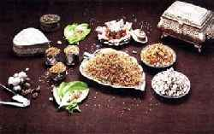

Pan Masala
Get Latest Price
Send Inquiry

Red Tobacco
Get Latest Price
Send Inquiry
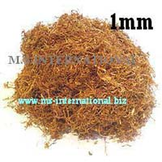

Cigarette Tobacco Blends
Get Latest Price
Send Inquiry
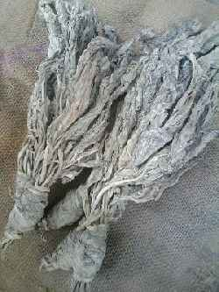

White Tobacco
Get Latest Price
Send Inquiry

You may also like
Herbal Bidi
Get Latest Price
Form: | Sticks
Packaging: | Packet
Gender: | Unisex
Shelf Life: | 24 month
Minimum Order Quanity: | 100 Packets
by: M S International
Send Inquiry
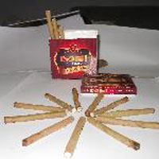
Herbal Bidi
Get Latest Price
Our Company are offering herbal bidi.. m..s..international offers good quality of the herbal bidi with different purposes if you need any kind of the herbal bidi pls contct us we can supply it.. Year of Estd.. : 1979 View More Details
by: M. S. International, Kanpur
Send Inquiry

Tell us what are you Looking for?
Enter Product/Service name
Enter City
Enter Minimum Quantity
--- Select Unit ---BagsSetsTonsFootBoxesUnitsPairsMeterPiecesCartonsKilogramContainerBarrelsBushelsCubic MeterDozenGallonGramsKilometerLong TonMetric TonOuncePacksPoundShort TonSquare MeterRollsBottlesLitersPacketsSheetsReamsOunce20' Container40' ContainerHectareNumberQuantity Type
Contact Person Name
Company Name
Enter Your Email
Submit Requirement

Customer Reviews
Write a Review
Overall Rating
3.3/5
Reviewed by 4 Users
Rating Breakdown
5
0
4
1
3
3
2
0
1
0
Most Helpful Reviews

Value For Money, Response, Product Variety
Ajmal khan | 6th August, 2021

Value For Money, Qualilty, Product Variety
Rohit Jain | 30th November, -0001

Value For Money, Qualilty, Product Variety
Mahammed Bhai | 30th November, -0001

Response, Qualilty, Product Variety
Akshay | 10th August, 2021

Value For Money, Qualilty, Product Variety
Rohit Jain | 30th November, -0001

Value For Money, Response, Product Variety
Ajmal khan | 6th August, 2021

Value For Money, Qualilty, Product Variety
Mahammed Bhai | 30th November, -0001
Load More Review
Get in touch with us
- M S International
166/3 Shastri Nagar, Kanpur, Uttar Pradesh, India - 208005
- Manish
General Links
- About Us
- Our Products
- Contact Us
Share Us:

Send Enquiry View Mobile Number
© 2023 M S International. All Rights Reserved. | Developed and Managed by Dial4Trade.Com

